A Project Report On

Fashionworld
(A web site that would provide information, old fashion new fashion )

Designed and Developed
By

Mr.IMRAN MOHAD FEROZ

Submitted In Partial Fulfillment of Academic Project
Bachelor of Science (Computer Science)

[University Of Mumbai]

ANJUMAN-I-ISLAM’S
AKBAR PEERBHOY COLLEGE
COMMERCE & ECONOMICS
M.S.ALI ROAD, DOTAKI,
MUMBAI – 400 008

ACADEMIC YEAR: 2009-2010

ANJUMAN-I-ISLAM’S
AKBAR PEERBHOY COLLEGE
COMMERCE & ECONOMICS
M.S.ALI ROAD, DOTAKI,
MUMBAI – 400 008

ACADEMIC YEAR: 2009-2010

CERTIFICATE

This is to certify that this report is submitted by

Name | Roll No
IMRAN S/O MOHAMMED FEROZ | 09

Students of Third Year Computer Science course as a part of project work as described by the University of Mumbai. The said work has been assessed by us and we are satisfied that the same is upto standard envisaged for the level of the course and therefore it can be presented to external examiner.

Subject-In-Charge Head of Department Principal External Examiner
Date: - _________ Date:-__________ Date:-________ Date:-__________



Acknowledgement

Developing this web site for the fashionworld has helped me a lot in not only understanding and implementing Web Technologies but has also given me immense knowledge on fashion, . While developing the site, many visits on the actual fashion Site have proved to be treasured experiences for me.

Firstly, I would like to thank my teacher and guide Prof. SADIQUE sir, the Head of the Computer Department, Who gave me his valuable suggestions and ideas whenever I was in need of them. He encouraged me to work on this project and put my heart and soul into it. I would also like to thank Prof. sadique sir, for imparting immense knowledge about Web Technologies to me.

I am thankful to Mr. HANIF LAKDAWALA (ASSISTANT DIRECTOR) AND DR.SHAIKH MEHMOOD HASSAN (PRINCIPAL) for their help and co-ordination during the development of project.

We also thank our Lab Assistants Mr. ALTAF CHOUGULE for providing us with the necessary laboratory facilities whenever required.

I am immensely grateful to all involved in this project because without their inspiration, constant prompting and useful suggestion, it would not have been possible to bring out this project in allotted time.

I sincerely appreciate the help provided by all those in the careful preparation of the project.

Index
Title | Page No
Introduction and Purpose | 3 - 4
URL/Content | 5
Uploading Methods | 6
Site Map | 7
Site Structure/Block Diagram | 8
User’s of the Site | 9
Database Details | 10
Technologies and Hardware Used | 11
Maintenance and Upgradations | 12
Screenshots | 13 - 56
Source Code | 57 - 66
Limitations and Future Enhancements | 67
Bibliography | 68

Introduction

- Site developed for whom?

This site was developed for them who want on-line fashion information .

- Purpose of the Site

This website gives the full information of Exciting Fashionworld for everyone. The purpose of this site is to provide facilities for the user to on-line fashion and collect the information about particular fashion, available.

Users come to the site to see something about the available Fashion infomation, to collect on. Considering all the needs of the users, site is developed for them. The site provides easy user access by providing all information at a click.

- Scope of the Site

  - This website contains the information about many exciting new and old fashion information & provides a view of dress design & shoes.

  - This Website contains the Sitemap using which visitor can directly go to the page he is looking for.

  - This Website contains the Feedback form which allows visitor to send his comments to the designer of the website.

The main advantages of this site are as follows: -

  - User Satisfaction.
This site provides all the information without much effort and wastage of time. Hence, users are satisfied with the site

  - Easy to use.
Users can achieve their goal with effectiveness, efficiency and satisfaction in a specified context of use.

  - Easy availability of information.
User can easily get the information from the site just on a single click.

  - Efficient to use.
As the site is error free, user can efficiently surf the site to get the required information and to achieve their goal.

  - Easy navigation.
Appropriate links are provided for easy navigation for the user through the site.



URL for the website:
A URL (Uniform Resource Locator) on the web gives the precise location to the users. Thus URL identifies the address or location of resource on internet. The URL for this site is:-

www.Fashionworld.com

Site Map

HOME
70,s
80,s
90,s
CURRENT
PERSONALIZE
FEEDBACK
SHOES OF 70,s
SHOES OF 80,s
SHOES OF 90,s
CURRENT SHOES

Site Structure

The site structure is Web, Organizational & Tutorial. You can go to one page to next page in a category. To goto the next category user will have to goto the main page then click on the appropriate link for that category. The maximum page depth varies.

Block Diagram

Image
Website Heading

Links

Image

DESCRIPTION

Image

Database Details

Any user visiting the site can give his/her feedback about the site. The feedback is saved in the feedback table of database Mumbai and viewed online by the administrator of the site by logging in.

Table Details:

Table Name: admin

Field | Type
username | Text
password | Text

Table Name: feedback

Field | Type
Feedbackid | AutoNumber
name | Text
email | Text
comments | Text





Software technologies:

- Database Used:-
Ms. Access is the relational DBMS is a part of Ms Office suit.
FeedBack.mdb is the database for this project.

- Drivers used :-
Ms Access Driver (*.mdb) :-
With Access driver installed, It is easy to access any ‘.mdb’ file with any server ,to retrieve ,update or delete the database information.

- Provider Used: -
MICROSOFT.JET.OLEDB.4.0

- Language Used: -

  - HTML (Hyper Text Markup Language): -

HTML is a document-layout and hyperlink specification language. It defines the syntax and placement of special, embedded directions that aren’t displayed by the browser, but tell it how to display the contents of the document, including text, images, and other support media. The language also tells you how to make a document interactive through special hypertext links, which connect your document with other documents—on either your computer or someone else’s, as well as with other Internet resources, like FTP and Gopher.

  - VBSCRIPT Language: -

Microsoft’s Visual Basic Scripting Edition (VBScript) enables you to embed commands into an HTML document. VBScript is an interpreted language; IE interprets the VBScript commands when they are loaded and run. VBScript is a fast and Flexible subset of Microsoft’s Visual Basic and Visual Basic for Application languages and is designed to be easy to program in and quick in adding active content to HTML documents.

  - JavaScript Language: -
JavaScript enables you to embed commands in an
HTML page. When a compatible Web browser, such as Netscape Navigator 2 or higher or Internet Explorer 3 or higher, downloads the page, the Web browser as a part of the HTML document loads your JavaScript commands. These commands can be triggered when the user clicks page items, manipulates gadgets and fields in an HTML form, or moves through the page history list. JavaScript provides a fairly complete set of built-in functions and commands, enabling you to perform math calculations, manipulate strings, play sounds, open new windows and new URLs, and access and verify user input to your Web forms.

  - CSS (Cascading Style Sheet): -
Cascading Style Sheets offer separate means of
controlling the display of Web pages, with the intent of resorting HTML to its original structural purpose. They are collections of style information that are applied to plain text. Internal style sheet is used in this site. All the style information are embedded within the <style>..</style> tags inside the <head>..</head> tags.

  - ASP (Active Server Pages): -
Active Server Pages (ASP) is a server-side scripting
environment that you can use to create dynamic web pages or build powerful Web applications. ASP pages are files that contain HTML tags, text and script commands. ASP pages can call ActiveX components to perform tasks, such as connecting to a database or performing a business calculation. With ASP,you can add interactive content to your Web pages or build entire Web applications that use HTML pages as the interface to your customer. ASP applications are easy to develop and modify. Inclusive files can also be included with ASP.

  - SQL (Structured Query Language): -
An SQL language is used to build queries while inserting and retrieving records from databases.

Hardware technologies:

- Machine configuration:
- Processor: Pentium III minimum-500 MHz
- RAM: 128MB preferable
- Platform: Windows 98 , NT or Better
- Monitor: 17” Samsung preferable
- Resolution: 1024 & 768 pixel

- Why such technology is preferred: -
ASP is a standard HTML file that is extended with additional
Features. It can contain server-side scripts. By including server-side scripts in an Active Server Page, we can create Web page that displays different messages at different times of day.
An ASP provides several built-in objects. By using the built-in objects accessible in an ASP, we can make our scripts much more powerful. Among other things, these objects enable to both retrieve information from and send information to the browsers. They are also provided with additional components, which can be used to do thing like work with databases, send email, and access the file system.
The hardware and software technologies used in the development of this site is the most commonly available, efficient, portable and user as well as designer friendly technology in market, at present.

- FEASIBILITY STUDY

The very first phase in any system developing life cycle is preliminary investigation. The feasibility study is a major part of this phase. A measure of how beneficial or practical the development of any information system would our following aspects:

- OPERATIONAL FEASIBILITY:
The site will reduce the time consumed to maintain manual records and is not tiresome and cumbersome to maintain the records. Hence operational feasibility is assured.

- Why such technology is preferred: -

ASP is a standard HTML file that is extended with additional
features. It can contain server-side scripts. By including server-side scripts in an Active Server Page, we can create Web page that displays different messages at different times of day.
An ASP provides several built-in objects. By using the built-in objects accessible in an ASP, we can make our scripts much more powerful. Among other things, these objects enable to both retrieve information from and send information to the browsers. They are also provided with additional components, which can be used to do thing like work with databases, send email, and access the file system.
The hardware and software technologies used in the development of this site is the most commonly available, efficient, portable and user as well as designer friendly technology in market, at present.

Extra Facilities or Services Provided by the Web Site
( Search Engine, Emails, portals, etc. )

This web site does not provide any facility such as Search Engine,
Emails, portals, etc.

Limitations and Future Enhancements

Limitations: -

This site does not include search engine facility. So users cannot
Search a particular topic from this site.

No external links are provided to get information about various
other entertainment categories.

Future Enhancements: -

In future I would like to bring some modifications in my site.

External links would be provided to get information about various other fashion categories.

An online guide would be provided for answering some of the frequently asked questions posted by the users.

Maintenance and Up gradation of the Site

The fashion information will be updated after every week, month and year and also depending on the users contribution.

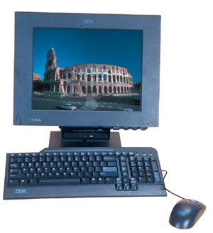

HOME

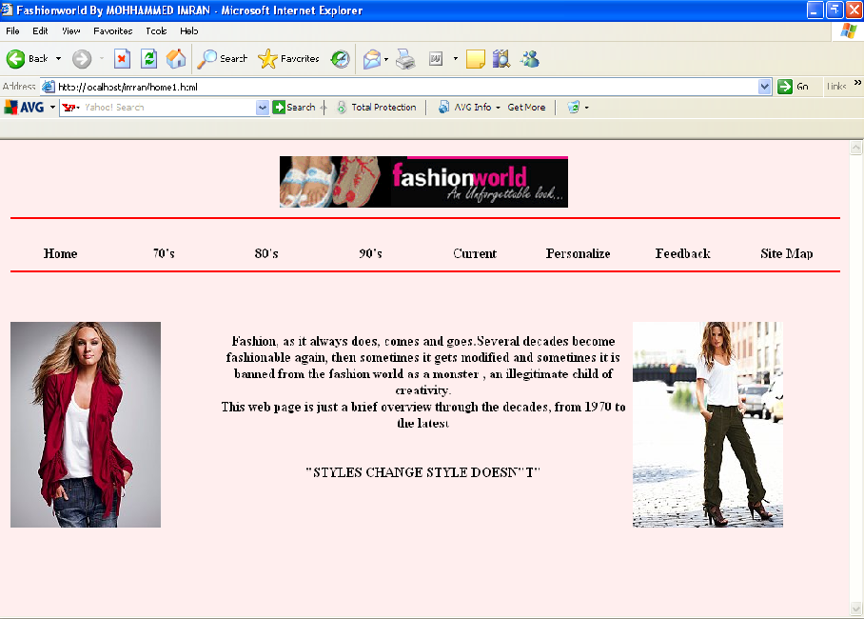

70’s DESIGN PAGE

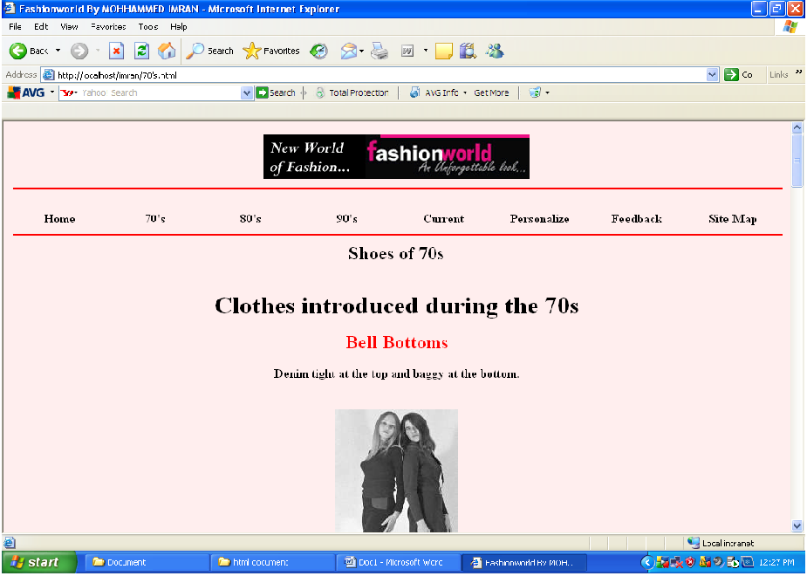

70,s SHOES

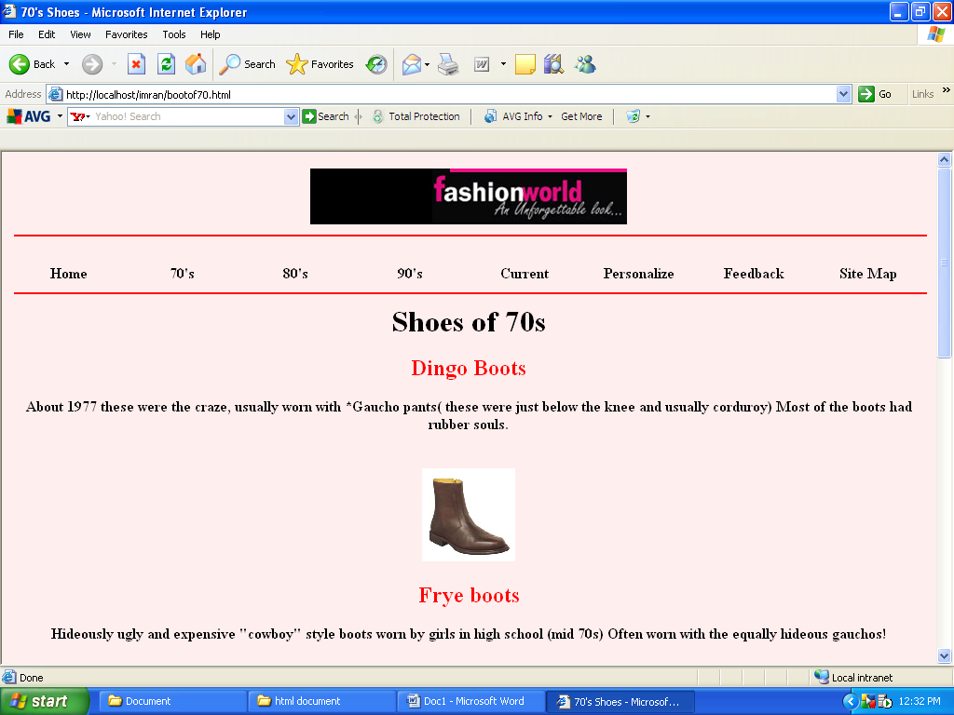

80,s DESIGN

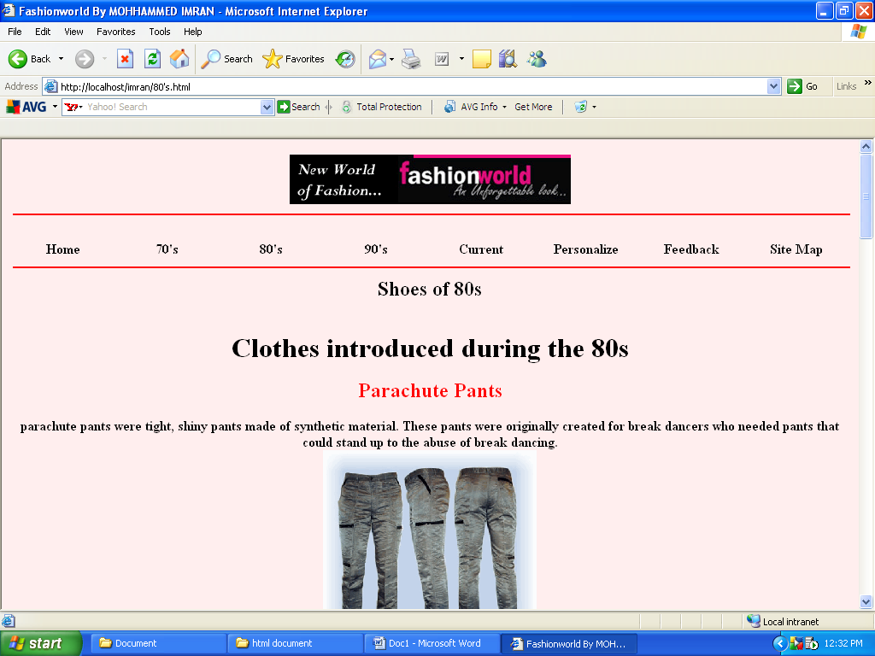

80,s SHOES

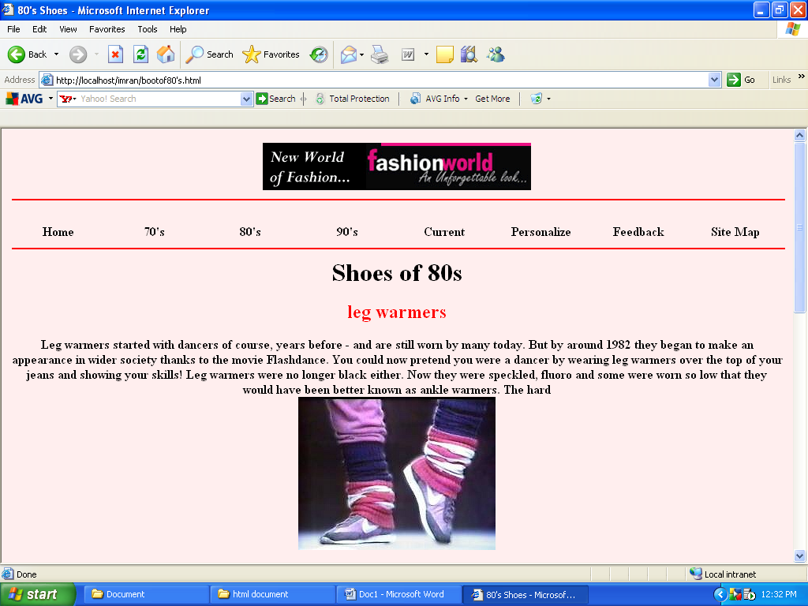

90,s DESIGN

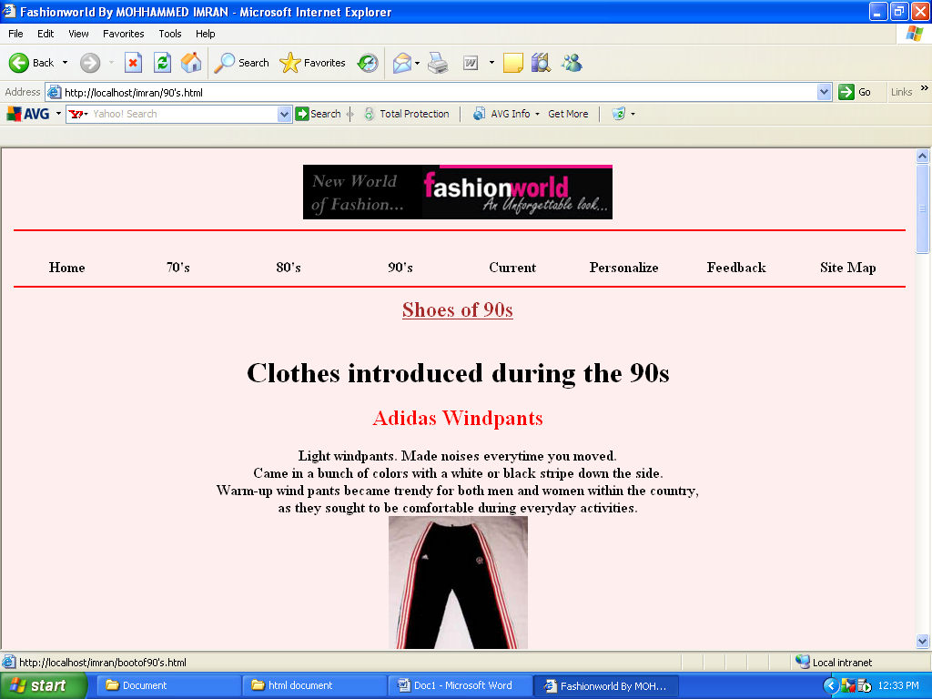

90,s SHOES

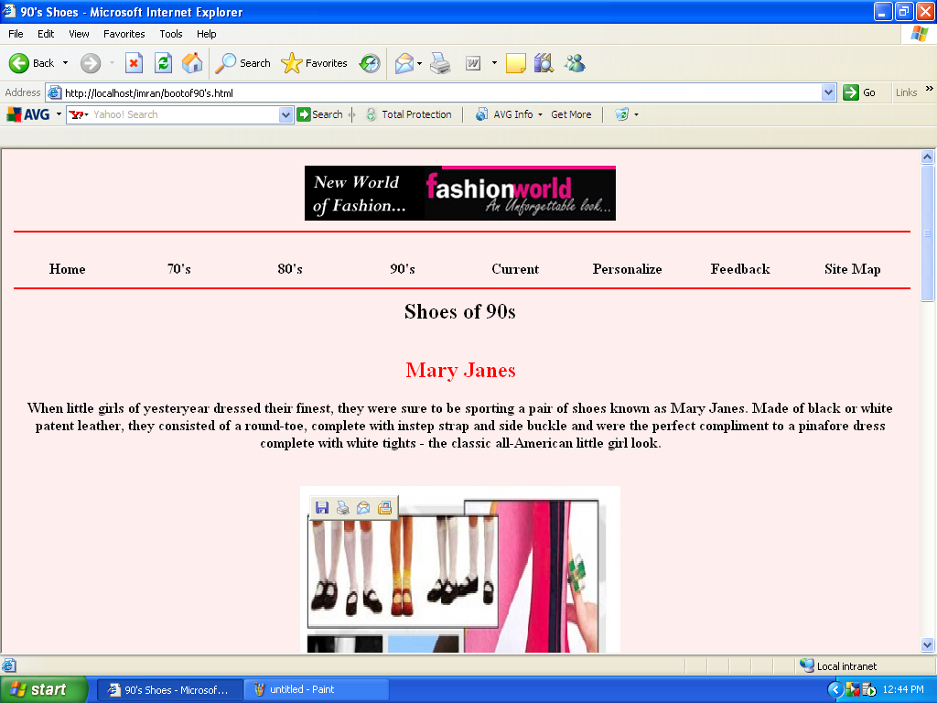

Current DESIGN

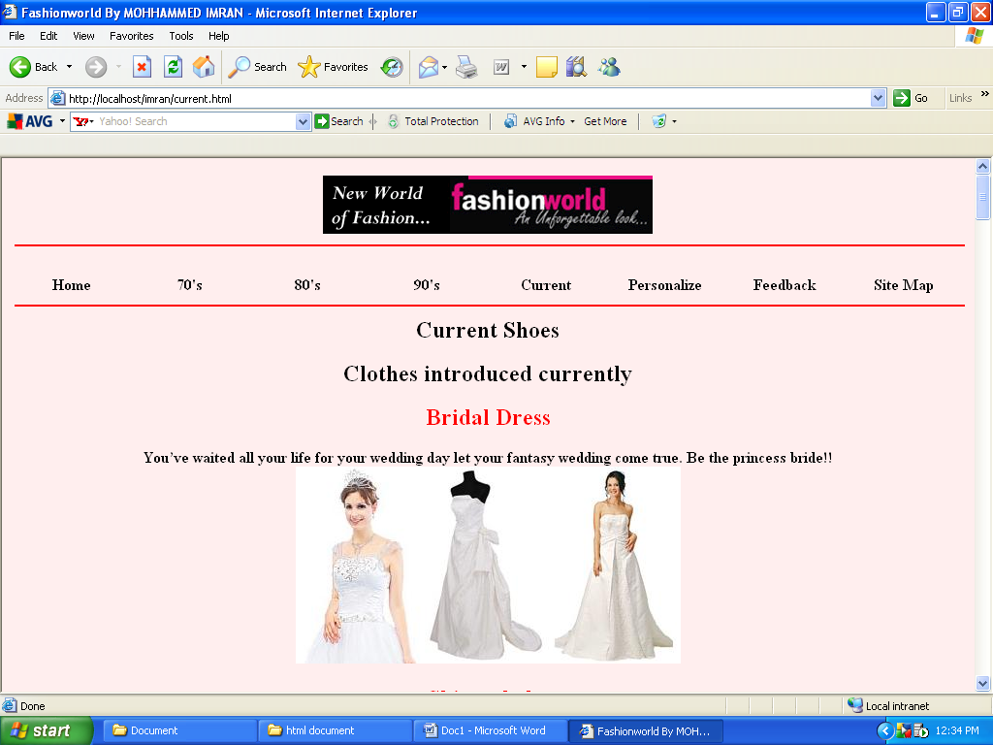

Current shoes

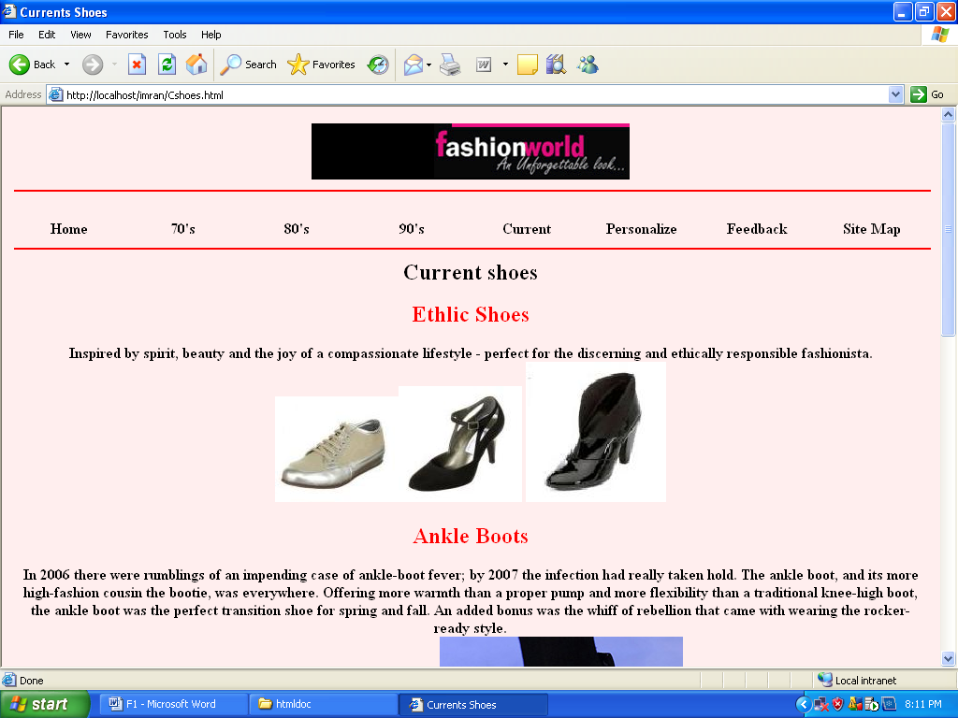

Sitemap

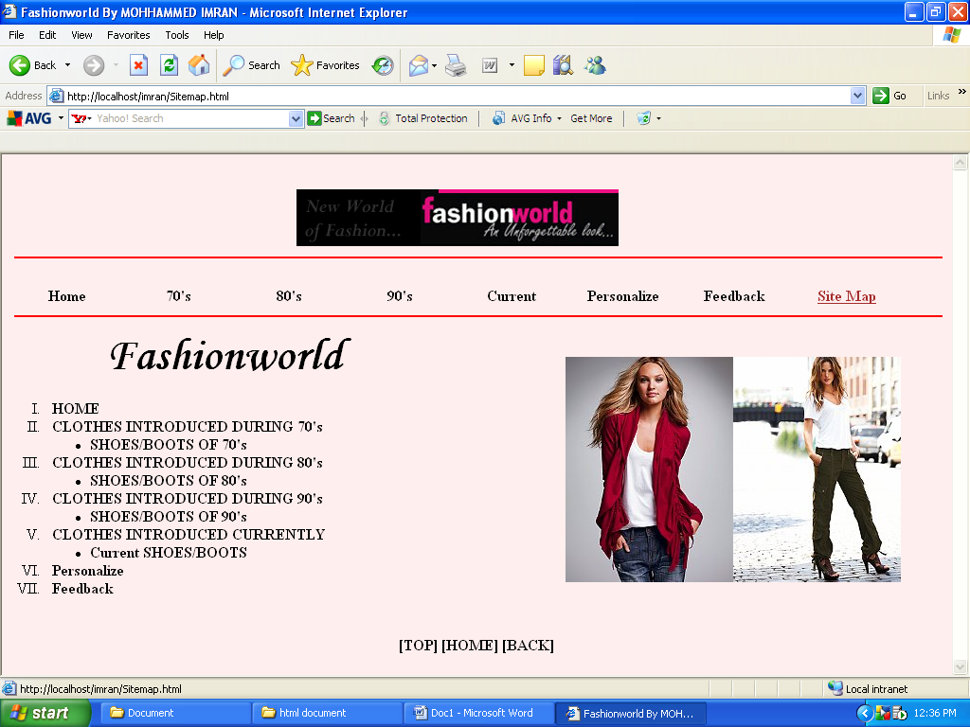

Feedback

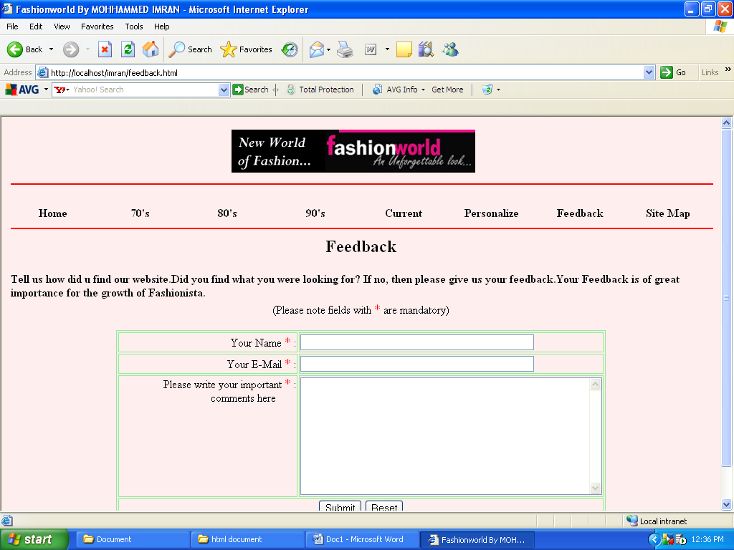

Personalize

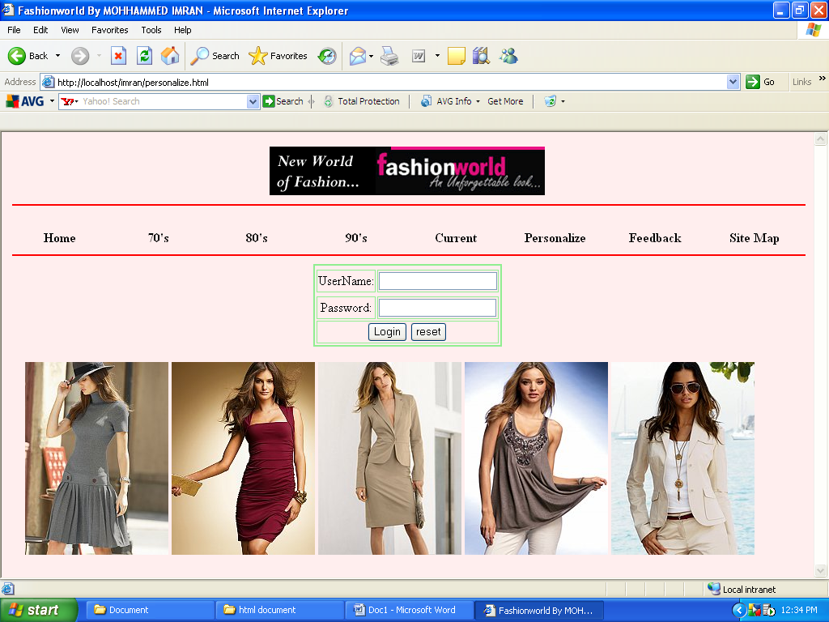

Loginsucessfully

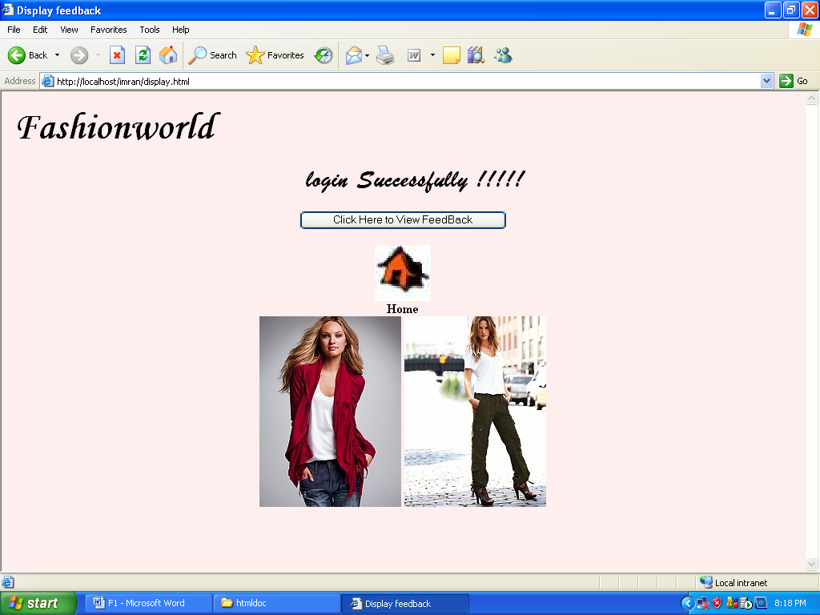

Feedback checking

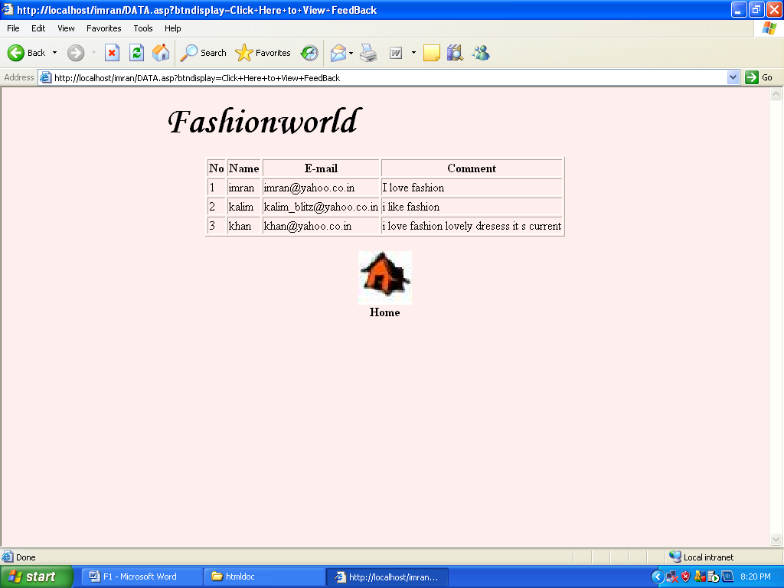



HTML-Code

Fashionworld (HOME)
<html>
<head>
<link href="b.css" type="text/css" rel="stylesheet">
</head>
<title>Fashionworld By MOHHAMMED IMRAN</title>

<body bgcolor=ffeeee>
<table align="center">
<tr>
<td colspan=8 align="center"><img border=0 src="logo.gif"></td>
</tr>

<tr>
<td colspan=8> <hr size=2 color=red width=150% > </td>
</tr>

<tr>
<th width="12.5%"><a href="home1.html"><br> Home</a></th>
<th width="12.5%"><a href="70's.html"><br>70's </a></th>
<th width="12.5%"><a href="80's.html"><br>80's</a></th>
<th width="12.5%"><a href="90's.html"><br>90's</a></th>
<th width="12.5%"><a href="current.html"><br>Current</a></th>
<th width="12.5%"><a href="personalize.html"><br>Personalize</a></th>
<th width="12.5%"><a href="feedback.html"><br>Feedback</a></th>
<th width="12.5%"><a href="Sitemap.html"><br>Site Map</a></th>
</tr>

<tr>
<td colspan=8> <hr size=2 color=red width=150%> </td>
</tr>

<tr>
<td colspan=2>&nbsp;</td>
<th colspan=4 rowspan=7 ><font color="black" ><What is fashion???Well,it defines the popular or up-to-date way of dressing,speaking or behaving.<br>
Fashion, as it always does, comes and goes.Several decades become fashionable again, then sometimes it gets modified and sometimes it is banned from the fashion world as a monster , an illegitimate child of creativity.
</br>
This web page is just a brief overview through the decades, from 1970 to the latest<br><br><br>
"STYLES CHANGE STYLE DOESN"T"

<br>
</th>
<td colspan=2>&nbsp;</td>
</tr>

<tr>
<td colspan=8><br></td>
</tr>

<tr>
<td colspan=2><img border=0 src="001.jpg"></td>
<td colspan=6><img border=0 src="002.jpg"></td>

</tr>
<tr>
<!--<td colspan=4><marquee><img border=0 src="GlamLifeStyle.gif"></marquee></td>
<td colspan=4> <marquee> <img border=0 src="logo.png"></marquee></td>
<td colspan=2><marquee><img border=0 src="options.gif"></marquee></td>-->

</tr>
</table>
</body>

70,s (design)
<html>
<head>
<link href="b.css" type="text/css" rel="stylesheet">
</head>
<title>Fashionworld By MOHHAMMED IMRAN</title>

<body bgcolor=ffeeee>
<table align=center border=0>
<link href="b.css" type="text/css" rel="stylesheet">
<tr>
<td colspan=8 align="center"><img border=0 src="logo.gif"></td>
</tr>

<tr>
<td colspan=8> <hr size=2 color=RED width=150% > </td>
</tr>
<tr>
<th width="12.5%"><a href="home1.html"><br> Home</a></th>
<th width="12.5%"><a href="70's.html"><br>70's</a></th>
<th width="12.5%"><a href="80's.html"><br>80's</a></th>
<th width="12.5%"><a href="90's.html"><br>90's</a></th>
<th width="12.5%"><a href="current.html"><br>Current</a></th>
<th width="12.5%"><a href="personalize.html"><br>Personalize</a></th>
<th width="12.5%"><a href="feedback.html"><br>Feedback</a></th>
<th width="12.5%"><a href="Sitemap.html"><br>Site Map</a></th>
</tr>
<tr>
<td colspan=8> <hr size=2 color=red width=150%> </td>
</tr>

<tr>

<th colspan=8 rowspan=10 ><font color="black"><a href="bootof70.html"><H2>Shoes of 70s</font></h2></a><br>
<h1>Clothes introduced during the 70s</h1>

<P><h2><font color="red">Bell Bottoms</font></h2></p>
Denim tight at the top and baggy at the bottom.</p><br><img border=0 src="mod.jpg">

<P><h2><font color="red">Angel Sleaved Blouses</font></font></h2></p>
<p>Loose cut, oversized blouses with "bell bottom" sleeves. All Cotton.</p><br><img border=0 src="bettye2.jpg" width="123"
height="200">

<P><h2><font color="red">Cheese cloth</font></h2> </p>
<p>Shirts, dresses, skirts anything was made from cheese cloth, it was crinkly so you didn't need to iron it.
It used to shrink sometimes just on the first wash sometimes with every wash.
If it was cream coloured you had to soak it in cold tea after washing to keep its colour.</p><br><img border=0 src="jean.jpg">

<P><h2><font color="red">Corduroy!</font></h2></p>
<p>Originally known as the "poor man's velvet" on its invention in the 18th century, this fabric is made with the
warp higher than the weft, producing an eye-catching look similar to velvet, but much, much cheaper. Corduroy
enjoyed enormous popularity in 1970's men's clothes and was made into suits, blazers, leisure suits, shirts,
and jeans ("cords"). Popular colors were various shades of tan and brown, burgundy, and bottle-green.
The fabric also appeared made into women's skirts, but on the whole it was thought of by designers as a men's
material. Corduroy suffered greatly from its association with the 1970's - items made in this fabric vanished
after 1981 and have been impossible to find until right now - Fall 2000.</p> <br><img border=0 src="cords.jpg">

<P><h2><font color="red">Satin jackets</font></h2></p>
<p>Happy Days did more than just give people a reminiscent trip down Memory Lane; it gave us a happy look back on yesteryear’s fashions… which, if you were wondering, included the likes of the satin jacket. Ever popular at the sock hop, the 70s helped this one-time “Members Only” trend come into its own.</p><br>
<img border=0 src="satin.jpg">

<P><h2><font color="red"> Fringed Suede Vest/Jacket </font></h2></p>
<p> If you could afford one, a suede vest or jacket with long fringes around the middle and/or bottom made
quite a fashion statement!</p><br> <img border=0 src="jacket.jpg" width="150" height="100">

<P><h2><font color="red"> Goucho Pants </font></h2></p>
<p>A coulotte type worn by high school girls that went below the knee, usually colorful, sort of a Mexican
look. Usually worn with high leather boots that lace up. Early 70's look.</p> <br><img border=0 src="gau.jpg" width="150" height="100">

<P><h2><font color="red"> Hang Ten satin jackets </font></h2></p>
<p>Pink, blue and maybe green. They were huge in the disco era ( late 70's). They had white and the jacket
color stripes around the sleeves and the collar.</p><br><img border=0 src="hang.jpg" width="150" height="100">

<P><h2><font color="red"> Hotpants </font></h2></p>
<p>Very short dressy shorts,usually plush velvet, with a wide,usually white ,belt,to match your white
go-go boots. </p><br><img border=0 src="hot.jpg">

<P><h2><font color="red"> Maxi Dresses </font></h2></p>
<p>Full length dresses for parties, etc, like a bridesmaid's dress, worn with choker and crochet shawl,
usually a fitted bodice and A-line skirt </p><br><img border=0 src="maxi.jpg" width="150" height="100">

<P><h2><font color="red"> Peasant Skirt </font></h2></p>
<p>A trendy knee-length skirt with a swinging movement. The most popular colors were black, white, beige,
tawny, tan, pink, blue, red, purple, gray, burgundy( definately bungundy) and pea green.</p><br><img border=0 src="peas.jpg" width="150" height="100">

<P><h2><font color="red">Wrap dress </font></h2></p>
<p>MEMORIES:
More Memories »
JenniferJuniper remembers...
Wrap dresses were wonderful until it was time to sit down, and then that wrap came UNwrapped. They should have ... More »
Posted on 07/26/07 Women in the 1970’s needed something new - a style both simple and sophisticated for an active life. Diane Von Furstenberg to the rescue! In 1973 the fashion designer and former royal socialite introduced the wrap dress. Suddenly a new generation of women had something they could wear to the disco, the office, and almost anywhere in between – like the “little black dress” of the 60’s, but way more sensible. </p> <br>
<img border=0 src="skor.jpg">
<p align="center"><a href="#top">[TOP]</a> <a href="home1.html">[HOME]</a>
<a href="javascript:history.back(1)">[BACK]</a><br>
</p></th>
</tr>
</table>
</body>
</html>

70,s (Shoes)

<html>
<head>
<link href="b.css" type="text/css" rel="stylesheet">
</head><title> 70's Shoes</title>
<body bgcolor=ffeeee>
<table align=center border=0>

<table align=center border=0>

<tr>
<td colspan=8 align="center"><img border=0 src="logo.gif"></td>

</tr>

<tr>
<td colspan=8> <hr size=2 color=RED width=150% > </td>
</tr>
<tr>
<th width="12.5%"><a href="home1.html"><br> Home</a></th>
<th width="12.5%"><a href="70's.html"><br>70's</a></th>
<th width="12.5%"><a href="80's.html"><br>80's</a></th>
<th width="12.5%"><a href="90's.html"><br>90's</a></th>
<th width="12.5%"><a href="current.html"><br>Current</a></th>
<th width="12.5%"><a href="personalize.html"><br>Personalize</a></th>
<th width="12.5%"><a href="feedback.html"><br>Feedback</a></th>
<th width="12.5%"><a href="Sitemap.html"><br>Site Map</a></th>
</tr>
<tr>

<td colspan=8> <hr size=2 color=red width=150%> </td>
</tr>

<th colspan=8 rowspan=10 ><font color="black"><H1>Shoes of 70s</H1>

<h2><font color="red"> Dingo Boots </font></h2>
<P>About 1977 these were the craze, usually worn with *Gaucho pants( these were just below the knee and usually
corduroy) Most of the boots had rubber souls.</p><br><img border=0 src="dingo.jpg" width ="100" height="100">

<h2><font color="red"> Frye boots </font></h2>
<p> Hideously ugly and expensive "cowboy" style boots worn by girls in high school (mid 70s) Often
worn with the equally hideous gauchos!</p><br> <img border=0 src="frye.jpg" width="200" height="150">

<h2><font color="red">Moon Boots </font></h2>
<p>Winter boots with platforms that looked like something Neil Armstrong would have worn - except for
the colours.</p><br><br> <img border=0 src="moon.jpg" width="150" height="150">

<h2><font color="red"> Wallabies </font></h2>
<p> They were these shoes that were very popular. The soles were rubbery and would sometimes seem to melt.
They were tan and had a lace and two lace holes. Tan suede shoes with crepe-rubber soles, a lace and two lace
holes. A little like a desert boot crossed with a moccasin.<p><br><img border=0 src="wall.jpg" width="150" height="150">
<br><br><br>

<p align="center"><a href="#top">[TOP]</a> <a href="home1.html">[HOME]</a>
<a href="javascript:history.back(1)">[BACK]</a><br>
</p>

</table>
</body>
</html>

80,s(Design)

<html>
<head>
<link href="b.css" type="text/css" rel="stylesheet">
</head>
<title>Fashionworld By MOHHAMMED IMRAN</title>

<body bgcolor=ffeeee>
<table align= center>

<tr>
<td colspan=8 align="center"> <img border=0 src="logo.gif" width="329"></td>

</tr>

<tr>
<td colspan=8> <hr size=2 color=red width=150% > </td>
</tr>
<tr>
<th width="12.5%"><a href="home1.html"><br> Home</a></th>
<th width="12.5%"><a href="70's.html"><br>70's</a></th>
<th width="12.5%"><a href="80's.html"><br>80's</a></th>
<th width="12.5%"><a href="90's.html"><br>90's</a></th>
<th width="12.5%"><a href="current.html"><br>Current</a></th>
<th width="12.5%"><a href="personalize.html"><br>Personalize</a></th>
<th width="12.5%"><a href="feedback.html"><br>Feedback</a></th>
<th width="12.5%"><a href="Sitemap.html"><br>Site Map</a></th>
</tr>

<tr>
<td colspan=8> <hr size=2 color=red width=150%> </td>
</tr>

<tr>
<th colspan=8 rowspan=10 ><font color="black"><a href="bootof80's.html"><H2>Shoes of 80s</font></h2></a><br>
<H1>Clothes introduced during the 80s</H1>
<P><h2><font color="red">Parachute Pants </font></h2></p>
<P >parachute pants were tight, shiny pants made of synthetic material. These pants were originally created for break dancers who needed pants that could stand up to the abuse of break dancing.<br><img border=0 src="par.gif">
</P>

<P><h2><font color="red">Acid Washed Jeans</font></h2></p>
<p>One of the hottest and thankfully short lived trends in this decade of fashion oddities was wearing acid washed jeans. The acid washed jeans trend didn’t become popular until the mid to late eighties and faded four to five years later. This trend seemed to go hand in hand with the big hair phenomenon of the late 80s.<br> <img border=0 src="ac.jpg"></P>

<P><h2><font color="red"> haircuts </font></h2></p>
<p>From the bangs that reached for the heavens with frizzy passion, to the extremely asymmetrical new wave social hair statement, to the funky side ponytails walking hair-in-hair with the mullets, hairstyles in the 1980s were about excess, experimentation, and enough hairspray to protect our heads when the Russians dropped the bomb.
<img border=0 src="ha.jpg" width=150 height=150><img border=0 src="ha1.jpg" width=150 height=150><img border=0 src="ha2.jpg" width=150 height=150>
</p>

<P><h2><font color="red"> Earrings, Gold, Gilt and Glitz
</font></h2></p>
<P>Costume jewellery saw a great revival and huge gold earrings, or pearl and gilt earrings that got bigger as the 80s decade progressed were the final finishing touch. Diamante jewellery and pearls were worn day and evening without embarrassment. Gilt buttons the size of earrings were also used on suits and charm bracelets with chunky gold charms were revived from the sixties.<br><img border=0 src="dang.jpg" width="250" height="250">

<P><h2><font color="red"> Net / mesh shirts</font></h2></p>
<p> Sometimes less can certainly be more, but rarely when one is forking out their hard-earned bucks for it. And yet, somehow holes became trendy and less fabric for more money must have sounded like a fantasy that no fashion executive could have imagined in their wildest dreams. But in those wacky 80s, that’s exactly what the consumer wanted holes and plenty of them. <br>
<img border=0 src="net.jpg" width="250" height="250"></p>

<P><h2><font color="red"> Neon / fluorescent</font></h2></p>
<p> If one happened to be sensitive to bright colors, the 80s was probably a bad decade to live through. The onslaught of day-glo, neon, and fluorescent colors were something that one might expect from a bad acid trip, not from the fashion industry at large.
It all started innocently enough when folks like Madonna and Cyndi Lauper enhanced their look with brightly colored bracelets but things spiraled out of control from that point on - and swiftly. Soon, colors that were rarely witnessed in nature, unless one happened to cart a black light to the bottom of the ocean, were brightening everything from jewelry and make up, to every sort of clothing item imaginable, and even some that were decidedly unimaginable.
<br>
<img border=0 src="ne.jpg" width="250" height="250"></p>

<P><h2><font color="red"> Visors</font></h2></p>
<p> These sunglass/hat combinations were absolutely vital for the roller skater, beachgoer, or fashion diva. Created in hard plastic, or from fabrics like cotton or terry cloth, visors shaded the wearer's eyes from the sun, offering shade to the face when sunglasses weren't enough. </P><br>

<img border=0 src="vi.jpg" width="250" height="250"></p>

<br>

<p align="center"><a href="#top">[TOP]</a> <a href="home1.html">[HOME]</a>
<a href="javascript:history.back(1)">[BACK]</a><br>
</p>

</th>
</tr>
</table>
</body>
</html>

80,s(Shoes)

<html>
<head><title> 80's Shoes</title>
<link href="b.css" type="text/css" rel="stylesheet">
</head>
<body bgcolor=ffeeee>
<table align=center border=0>

<tr>
<td colspan=8 align="center"><img border=0 src="logo.gif"></td>

</tr>

<tr>
<td colspan=8> <hr size=2 color=RED width=150% > </td>
</tr>
<tr>
<th width="12.5%"><a href="home1.html"><br> Home</a></th>
<th width="12.5%"><a href="70's.html"><br>70's</a></th>
<th width="12.5%"><a href="80's.html"><br>80's</a></th>
<th width="12.5%"><a href="90's.html"><br>90's</a></th>
<th width="12.5%"><a href="current.html"><br>Current</a></th>
<th width="12.5%"><a href="personalize.html"><br>Personalize</a></th>
<th width="12.5%"><a href="feedback.html"><br>Feedback</a></th>
<th width="12.5%"><a href="Sitemap.html"><br>Site Map</a></th>
</tr>
<tr>
<td colspan=8> <hr size=2 color=red width=150%> </td>
</tr>
<th colspan=8 rowspan=10 ><font color="black"><H1>Shoes of 80s</H1>

<P><h2><font color="red">leg warmers</font></h2> </p>
<p>Leg warmers started with dancers of course, years before - and are still worn by many today. But by around
1982 they began to make an appearance in wider society thanks to the movie Flashdance. You could now pretend you were a
dancer by wearing leg warmers over the top of your jeans and showing your skills! Leg warmers were no longer black either.
Now they were speckled, fluoro and some were worn so low that they would have been better known as ankle warmers. The hard
<br><img border=0 src="warm.jpg">

<P><h2><font color="red">Jelly shoes</font></h2></p>
<p>Speaking of shoes, while some women wore the highest heels possible (and in the loudest colors available such as hot pink, purple and teal) others (especially younger women) were rebelling and wanted flat, comfy shoes. Jelly shoes were born. Jellies were flat, see thru plastic shoes that came in a variety of brands and colors.<br> <img border=0 src="jel.jpg"></p>

<P><h2><font color="red"> Tube socks, striped</font></h2></p>
<p> The tall, thick tubes of white cotton hugged your calves, and were topped off by two or three rings of colored stripes. Sometimes it was one color in the multi-stripe, but the most righteous was each stripe a different color.
<img border=0 src="tu.jpg" width="250" height="250"></p>

<p align="center"><a href="#top">[TOP]</a> <a href="home1.html">[HOME]</a>
<a href="javascript:history.back(1)">[BACK]</a><br>
</p>

</table>
</body>
</html>

90,s(Design)
<html>
<head>
<link href="b.css" type="text/css" rel="stylesheet">
</head>
<title>Fashionworld By MOHHAMMED IMRAN</title>

<body bgcolor=ffeeee>
<table align=center>

<tr>
<td colspan=8 align="center"><img border=0 src="logo.gif"></td>

</tr>

<tr>
<td colspan=8> <hr size=2 color=red width=150% > </td>
</tr>
<tr>
<th width="12.5%"><a href="home1.html"><br> Home</a></th>
<th width="12.5%"><a href="70's.html"><br>70's</a></th>
<th width="12.5%"><a href="80's.html"><br>80's</a></th>
<th width="12.5%"><a href="90's.html"><br>90's</a></th>
<th width="12.5%"><a href="current.html"><br>Current</a></th>
<th width="12.5%"><a href="personalize.html"><br>Personalize</a></th>
<th width="12.5%"><a href="feedback.html"><br>Feedback</a></th>
<th width="12.5%"><a href="Sitemap.html"><br>Site Map</a></th>
</tr>

<tr>
<td colspan=8> <hr size=2 color=red width=150%> </td>
</tr>

<tr>
<th colspan=8 rowspan=10 ><font color="black"><a href="bootof90's.html"><H2>Shoes of 90s</font></h2></a><br>
<H1>Clothes introduced during the 90s</H1>

<h2><font color="red">Adidas Windpants</font></h2>
Light windpants. Made noises everytime you moved.<br> Came in a bunch of colors with a white or black stripe down the side.<br> Warm-up wind pants became trendy for both men and women within the country,<br>
as they sought to be comfortable during everyday activities.<br><img border=0 src="wind.bmp">

<h2><font color="red">Bandanas</font></h2>
<p>Bandanas became marketing icons in the ‘80s,<br>
decked out with band logos and ninja symbols.<br>
Pieces of cloth with Ozzy, Pink Floyd and Def Leppard logos adorned the walls of teens.<br>
These bandanas were no longer stuffed into pockets, but rather rolled and wrapped around your neck,<br>
tied around your shaved head, or knotted around your forehead a
la Loverboy.<br><img border=0 src="band.jpg">

</P></P>

<P><h2><font color="red">Baby Doll Dresses</font></h2></p>
<p>Everyone had one. They were the dresses that were adorable and made you look like a baby.<br><img border=0 src="ba.jpg"> </p>

<P><h2><font color="red">Polo shirts
</font></h2></p>
<p>A virtual Noah’s Ark of critters was unleashed upon the public in the 80s, proudly adorning what was the pinnacle of preppy clothing, the polo shirt. Alligators, foxes, tigers, swans – all found their way upon this elite sports attire at one time or another and offered a stylish look embraced by generation upon generation for over 80 years.
</p> <br><img border=0 src="pol.jpg">

<P><h2><font color="red"> Overalls (coveralls) </font></h2></p>
<p> As I remember, over-alls came back into style. In the early 1990's (approx. 1990 -1991 - I think) Teens
wore their overalls in two ways: They wore their overalls with a belt, and let the 'front flap' and 'back
straps' hang straight down. The other way, was to only hook together one side of the overal straps, and leave
the opposite side open. I remember that this was popular when I was in was in the 6th grade. The popular over-all
styles were: light blue; or gray stone-washed; overalls, with lots of zippers and metal buttons down the</p><img border=0 src="cover.jpg" width="300" height="300" ><br><br>

<p> <h2><font color="red"> Piercing </font></h2></p>
<p>Getting your tounge, belly button, eyebrow, nipple, ect. Just whatever you could get pierced. Everyone
has one. It was something cool.
</p>

<P><h2><font color="red"> Suspenders </font></h2></p>
<p>Suspenders had been holding up pants for centuries before the craze of the late 70's and early 80's seized the fashion and brought it to back in the form of colorful clip-ons. </p><br><img border=0 src="sus.jpg">

<P><h2><font color="red">Belly shirts
</font></h2></p>
<p>What better way to show off your rock-hard abs than with a midriff-bearing belly shirt? Madonna certainly couldn’t think of one. The video for the debut single “Lucky Star” featured the pop princess in a cropped mesh shirt layered over short tank tops, and teenage girls everywhere ran for the scissors.

These short tees that showed off your belly were popular with boys as well.</p><br><img border=0 src="Bel.jpg" align="bottom">

<p align="center"><a href="#top">[TOP]</a> <a href="home1.html">[HOME]</a>
<a href="javascript:history.back(1)">[BACK]</a><br>
</p>

</th>
</tr>
</table>
</body>
</html>

90,s(Shoes)

<html>
<head>
<link href="b.css" type="text/css" rel="stylesheet">
</head><title> 90's Shoes</title>
<body bgcolor=ffeeee>
<table align=center border=0>

<tr>
<td colspan=8 align="center"><img border=0 src="logo.gif"></td>

</tr>

<tr>
<td colspan=8> <hr size=2 color=RED width=150% > </td>
</tr>
<tr>
<th width="12.5%"><a href="home1.html"><br> Home</a></th>
<th width="12.5%"><a href="70's.html"><br>70's</a></th>
<th width="12.5%"><a href="80's.html"><br>80's</a></th>
<th width="12.5%"><a href="90's.html"><br>90's</a></th>
<th width="12.5%"><a href="current.html"><br>Current</a></th>
<th width="12.5%"><a href="personalize.html"><br>Personalize</a></th>
<th width="12.5%"><a href="feedback.html"><br>Feedback</a></th>
<th width="12.5%"><a href="Sitemap.html"><br>Site Map</a></th>
</tr>
<tr>
<td colspan=8> <hr size=2 color=red width=150%> </td>
</tr>
<th colspan=8 rowspan=10 ><font color="black"><H2>Shoes of 90s</font></h2></a><br>
<P><h2><font color="red">Mary Janes</font></h2></p>
<p>When little girls of yesteryear dressed their finest, they were sure to be sporting a pair of shoes known as Mary Janes. Made of black or white patent leather, they consisted of a round-toe, complete with instep strap and side buckle and were the perfect compliment to a pinafore dress complete with white tights - the classic all-American little girl look.</p><br>
<img border=0 src="ma.jpg" width=350 height=350>
</p>

<P><h2><font color="red"> Reeboks</font></h2></p>
<P>In the late 80’s, Reebok introduced Pump technology, bringing the sneakers to the basketball court. Nike had sneakers with air pockets, but Reebok allowed the user to pump in as much air as they wanted, creating a custom fit. The company marketed the shoe as a cross-training athletic shoe and found a whole new audience.

</p><br><img border=0 src="ree.jpg">

<P><h2><font color="red"> Nike </font></h2></p>
<p>By 1988, however, sales were becoming slower and Nike was losing its traction in the market. It was time for a new slogan and the one that emerged was “Just Do It,”A challenge set forth to be fearless in ones endeavors, to ignore preconceived notions and strive for greatness. The public embraced this simple mantra and Nike’s reputation and sales catapulted back up to the number one position. Within a few years, NikeTown superstores were opening across the country, hawking a complete line of shoes and related sports apparel.The Most Popular sports wear for most of the 90s.</p><br>
<img border=0 src="nike.jpg">

<P><h2><font color="red"> Wedge heels </font></h2></p>
<p>Pretty much everything that could happen to shoes happened in the 70s. One strange-looking development was the wedge heel, which evolved from the platform shoe. It was easy to topple over while wearing platform shoes, with their awkward platform base and stack heel; wedge heels were supposed to be a bit safer. Whether they really were safer was a matter of opinion, but how often do safety and fashion meet, anyway? Either way you were walking on a six-inch tower, and that just ain’t natural. But it sure looked – well, it sure looked something.

</p><br><img border=0 src="wedge.jpg">

<!--<P><h2><font color="red">Thigh-high Stockings </font></h2></p>
<p> Basically over-the-knee stockings that girls wore with very short skirts. Introduced around 1995, the two
basic colors were black and white.
</p><br> <img border=0 src="thigh.jpg"witdh="150" height="150">-->

<p align="center"><a href="#top">[TOP]</a> <a href="home1.html">[HOME]</a>
<a href="javascript:history.back(1)">[BACK]</a><br>
</p>

</table>
</body>
</html>

Current (Design)

<html>
<head>
<link href="b.css" type="text/css" rel="stylesheet">
</head>
<title>Fashionworld By MOHHAMMED IMRAN</title>

<body bgcolor=ffeeee>
<table align=center>

<tr>
<td colspan=8 align="center"><img border=0 src="logo.gif"></td>

</tr>

<tr>
<td colspan=8> <hr size=2 color=red width=150% > </td>
</tr>
<tr>
<th width="12.5%"><a href="home1.html"><br> Home</a></th>
<th width="12.5%"><a href="70's.html"><br>70's</a></th>
<th width="12.5%"><a href="80's.html"><br>80's</a></th>
<th width="12.5%"><a href="90's.html"><br>90's</a></th>
<th width="12.5%"><a href="current.html"><br>Current</a></th>
<th width="12.5%"><a href="personalize.html"><br>Personalize</a></th>
<th width="12.5%"><a href="feedback.html"><br>Feedback</a></th>
<th width="12.5%"><a href="Sitemap.html"><br>Site Map</a></th>
</tr>

<tr>
<td colspan=8> <hr size=2 color=red width=150%> </td>
</tr>
<tr>
<th colspan=8 rowspan=10 ><font color="black">
<a href="Cshoes.html"><H2>Current Shoes</font></h2></a>
<h2>Clothes introduced currently</h2>
<h2><font color="red"> Bridal Dress </font></h2>
<P >You’ve waited all your life for your wedding day let your fantasy wedding come true. Be the princess bride!!<br>
<img border=0 src="b1.jpg"><img border=0 src="b2.jpg"><img border=0 src="b3.jpg">
</P>

<P><h2><font color="red">Skinny belts </font></h2></p>
<p>Watch for jackets, trousers, shorts and dresses all sold with skinny belts and corsage flowers .Belts had a
revival with the gypsy Boho look when the belts were slung low on the hip.Belts are now back on the waistline,
and these belts here, feature a mixed selection of buckles and clasps. Many more varieties than we saw
during the Eclectic Ethnic Era.<br><img border=0 src="be.jpg"> <img border=0 src="sk.jpg"></P>

<P><h2><font color="red">Fedoras </font></h2> </p>
<p>Hats are the must-have that will not go away, and after years of pageboy and cowboy hats dominating the
market, fedoras were the hat du jour for both men and women. The fedora's fashion cred was
assured after both Olsens — Mary-Kate and Ashley — as well as Justin Timberlake were seen repeatedly in the
casual topper. A great way to hide a bad-hair day or obscure tired eyes, fedoras are another example of classic
men's attire morphing into hipster must-have.<br><img border=0 src="fedora.jpg"></p>

<P><h2><font color="red"> Ombre Dress</font></h2></p>
<p>Glowing ombre dresses -- tye-dye's sophisticated older sister -- lit up spring runways in New York and
Toronto thanks to designers like Diane von Furstenberg, Alexander McQueen and Zoran Dobric. Bold yet breezy,
the perfect ombre dress is the summer must that can take you from brunch to cocktails to the beach without
breaking a sweat.<br><img border=0 src="om.jpg"></p>

<P><h2><font color="red">The Cinched Waist</font></h2></p>
<p>After a couple of seasons of voluminous fever, designers are finally cutting out the poof and bringing back
the cinched waist. Trim is in, so lose that shapeless tunic and show off your killer bod with high-waisted pencil
skirts like Jessica Alba and high-waisted trousers.<br><img border=0 src="jes.jpg"></p>

<P><h2><font color="red">Floral Print Dress</font></h2></p>
<p>This year, spring collections from the likes of Balenciaga (to the left), Prada and Marc Jacobs are taking a
cue from lush spring gardens and exploding with fresh floral prints of everything from sweet poppies and
carnations to elegant amaryllises and orchids. Keep your wardrobe in full bloom with a frock of fabulous
flowers in bright, pretty colours.<br><img border=0 src="flo.jpg"></p>

<P><h2><font color="red">Technicoloured Handbag</font></h2></p>
<p>Like a ray of sunshine, vibrant handbags are back this spring, and many celebrities are making big style
statements by pairing these shockingly vivid bags against a simple, monochromatic look. <br><img border=0 src="bagi.jpg">
<img border=0 src="col.jpg">
<img border=0 src="col2.jpg"><img border=0 src="col3.jpg"></p>

<P><h2><font color="red">Bright Tights </font></h2></p>
<p>It's hard to believe that just a couple of years ago women preferred baring their legs in subzero
temperatures to doing anything as sensible as wearing hosiery. That was before the explosion of leggings in
2006. This year the trend kept growing, literally, until the feet were finally covered. Crazy-colored tights
have taken hold, and at long last, wearing skirts in the dead of winter is bearable again.
Think turquoise à la Balenciaga or any of the numerous bright colors that were seen on the catwalk at
Emilio Pucci. Fuschia is particularly hot this year.<br><img border=0 src="ti.jpg"></p>

<P><h2><font color="red">Oversize Bags</font></h2></p>
<p>Think big! Move over clutches and baguettes; as far as bags are concerned this season, bigger is certainly
better. Almost every trendsetting celebrity has jumped on the oversize-bag-bandwagon (think Nicole Richie,
Beyoncé, and Kate Moss) – roomy carryalls are versatile (perfect for day and night) and practical (you can carry
your entire life in them!), as well as überstylish. And the best part of all? You can find this totally cute look
without breaking the bank. While we'd all love to tote a supersized Chloé bag around, many retail chains have
their own twist on big bags that are still super stylish! <br>
<img border=0 src="bag2.jpg"><img border=0 src="bag3.jpg"><img border=0 src="bag4.jpg"></p>

<P><h2><font color="red">Prom Dress</font></h2></p>
<p>There’s no better way to make your prom date say, “Wow!” than with classy, sassy 2009 prom dresses from shopshop.com. On this most special night of your high school career, you want to look and feel your best. Our best prom dresses are not only gorgeous but they’re made in limited numbers and designed by our very own designer, Andy Anand. That means you won’t walk onto the dance floor to see some other girl wearing your dress! No way, girlfriend! <br>
<img border=0 src="prom.jpg" ><img border=0 src="pro.jpg" ><img border=0 src="promdress.jpg" ></p>

<P><h2><font color="red">High-Waisted Jeans </font></h2></p>
<p>After years of struggling to keep their bellies and behinds from falling out of low-rise pants,
women finally got some coverage in 2007 with the comeback of high-waisted jeans. As usual, the trend got
an added boost from paparazzi favorites like Mischa Barton and Jessica Simpson, who were caught out and about
wearing high-riders, prompting women to rush out with open wallets to get their own pair.<br>
<img border=0 src="high.jpg"></p>

<p><h2><font color="red"> White Sunglasses </font></h2></p>
<p>At first glimpse, sunglasses with stark white frames seemed destined to be nothing more than an oddball
trend for Hollywood hipsters. After all, they're the polar opposite of the glamorous styles that have ruled
for the past several years. But the influence of early-adopting trendsetters like Drew Barrymore and Kirsten
Dunst could not be denied, and soon the cheerily cool frames had caught on like wildfire. The standout
shades can be found in nearly any style, but Ray-Ban Wayfarers reign supreme with the cool kids.<br>
<img border=0 src="sun.jpg"></p>

<p><h2><font color="red"> The Tent Dress </font></h2></p>
<p>The billowy, shapeless tent dress caused more than a few raised eyebrows when it first appeared in the
spring — "tentlike" not being the kindest description one can give a garment — but shoppers were quickly won
over. Light, airy and short, it was the perfect silhouette to beat the summer heat and gracefully disguise any
extra pounds. By midyear the style dominated the racks of high-end department stores and mass-market meccas like H&M
and Zara.<br><img border=0 src="dress.jpg"></p>

<p><h2><font color="red">Bangs </font></h2></p>
<p> Short, long or swept to the side, bangs have been the biggest and most accessible trend in hair this year.
Hot both on the runway (see model Irina Lazarenau) and the red carpet (see Reese Witherspoon), they were
really invigorated by Ms. Trendsetter herself Kate Moss who wore them Michelle-Pfeiffer-in-Scarface style.
<br><img border=0 src="mo.jpg"></p>

<br>

<p align="center"><a href="#top">[TOP]</a> <a href="home1.html">[HOME]</a>
<a href="javascript:history.back(1)">[BACK]</a><br>
</p>
</tr>
</table>
</body>
</html>

Current (Shoes)
<html>
<head>
<link href="b.css" type="text/css" rel="stylesheet">
</head><title> Currents Shoes</title>
<body bgcolor=ffeeee>
<table align=center border=0>

<tr>
<td colspan=8 align="center"><img border=0 src="logo.gif"></td>

</tr>

<tr>
<td colspan=8> <hr size=2 color=RED width=150% > </td>
</tr>
<tr>
<th width="12.5%"><a href="home1.html"><br> Home</a></th>
<th width="12.5%"><a href="70's.html"><br>70's</a></th>
<th width="12.5%"><a href="80's.html"><br>80's</a></th>
<th width="12.5%"><a href="90's.html"><br>90's</a></th>
<th width="12.5%"><a href="current.html"><br>Current</a></th>
<th width="12.5%"><a href="personalize.html"><br>Personalize</a></th>
<th width="12.5%"><a href="feedback.html"><br>Feedback</a></th>
<th width="12.5%"><a href="Sitemap.html"><br>Site Map</a></th>
</tr>

<tr>
<td colspan=8> <hr size=2 color=red width=150%> </td>
</tr>

<th colspan=8 rowspan=10 ><font color="black"><H2>Current shoes</font></h2></a>

<P><h2><font color="red">Ethlic Shoes</font></h2></p>
<p>Inspired by spirit, beauty and the joy of a compassionate lifestyle - perfect for the discerning and ethically responsible fashionista. <br>
<img border=0 src="e1.jpg" ><img border=0 src="e2.jpg" > <img border=0 src="e3.jpg" width="150" height="150"></p>
<P><h2><font color="red">Ankle Boots </font></h2></p>
<p>In 2006 there were rumblings of an impending case of ankle-boot fever; by 2007 the infection had really
taken hold. The ankle boot, and its more high-fashion cousin the bootie, was everywhere. Offering more warmth
than a proper pump and more flexibility than a traditional knee-high boot, the ankle boot was the perfect
transition shoe for spring and fall. An added bonus was the whiff of rebellion that came with wearing the
rocker-ready style.
<br>
<img border=0 src="booties.jpg"> <img border=0 src="an.jpg"> </p>

<P><h2><font color="red">Satin Flats</font></h2></p>
<p>These sweet satin flats give new meaning to affordable style. The versatile shoes have a round-toe and
pretty bow, and are dressy enough to be worn with anything from gowns to jeans.Talk about sure-footing: For
spring, flats remain a must-have accent, but the big news is that dainty, ballerina-inspired styles are now de rigueur.
First worn by dancers during their studio hours then co-opted by Audrey Hepburn in the '60s, flats in black
leather and beribboned styles make their return for spring. <br>
<img border=0 src="ut.jpg" width="150" height="150"><img border=0 src="bal.jpg" width="150" height="150"></p>

<P><h2><font color="red">GreekShoes</font></h2></p>
<p>The shoes will be basically the platform shoes, ornaments and tassels and fringes, and many drafts openings, Greek or Roman style, and indeed, the famous shoe heel and pointed the needle of Balenciaga Autumn Winter 2009 collection<br>
<img border=0 src="cbott1.jpg" ><img border=0 src="cbott2.jpg" > </p>

<p align="center"><a href="#top">[TOP]</a> <a href="home1.html">[HOME]</a>
<a href="javascript:history.back(1)">[BACK]</a><br>
</p>

</table>
</body>
</html>

Personalize

<html>
<head>
<link href="b.css" type="text/css" rel="stylesheet">
<title>Fashionworld By MOHHAMMED IMRAN</title>
<SCRIPT LANGUAGE="JavaScript">

function Validate()
{
if(document.form.username.value=="")
{
alert("Please Enter User Name");
documentdocument.form.username.focus();
return false;
}
if(document.form.password.value=="")
{
alert("Please Enter Password!");
document.form.password.focus();
return false;
}
return true;
}

</Script>
</head>

<body bgcolor=ffeeee>
<form name="form" method="get" action="http://localhost/imran/loginprocess.asp">
<table align="center" width="100%">
<tr>
<td colspan=8 align="center"><img border=0 src="logo.gif"></td>
</tr>

<tr>
<td colspan=8> <hr size=2 color=red width=150% > </td>
</tr>

<tr>
<th width="12.5%"><a href="home1.html"><br> Home</a></th>
<th width="12.5%"><a href="70's.html"><br>70's</a></th>
<th width="12.5%"><a href="80's.html"><br>80's</a></th>
<th width="12.5%"><a href="90's.html"><br>90's</a></th>
<th width="12.5%"><a href="current.html"><br>Current</a></th>
<th width="12.5%"><a href="personalize.html"><br>Personalize</a></th>
<th width="12.5%"><a href="feedback.html"><br>Feedback</a></th>
<th width="12.5%"><a href="Sitemap.html"><br>Site Map</a></th>
</tr>
<tr>

<td colspan=8> <hr size=2 color=red width=150% > </td>
</tr>

<table border=2 bordercolor="lightgreen" align="center" >
<tr>
<tr><td align="center">UserName:</td>
<td><input type="text" name="username" size=20></td></tr>

<tr>
<tr><td align="center">Password:</td>
<td><input type="password" name="password" size=20></td></tr>
<tr align="center">

<td colspan=2>
<input type="submit" name="btnlogin" value="Login" onClick="return Validate()" value="Login" >

<input type=reset name="reset" value="reset">
</td>
</tr>

</table>
<br>
<tr><marquee behavior="alternate">
<td colspan=2><img border=0 src="019.jpg"></td>
<td colspan=6><img border=0 src="018.jpg"></td>
<td colspan=6><img border=0 src="014.jpg"></td>
<td colspan=6><img border=0 src="015.jpg"></td>
<td colspan=6><img border=0 src="016.jpg"></td>

</marquee>

</tr>
</form>
</body>
</html>

FeedBack

<html>
<head>
<link href="b.css" type="text/css" rel="stylesheet">
<title>Fashionworld By MOHHAMMED IMRAN</title>
<script language="JavaScript">
<!--
var num1,num2,num3;
function validateName()
{
var strName;
strName=document.Feedback.Name.value;
var name=/[^a-z .]/gi;
if(name.test(strName)==true || strName=="")
{
alert("Enter Valid Name!!!!");
document.Feedback.Name.focus();
document.Feedback.Name.select();
num1=0;
}
else
num1=1;
}

function validateEmail()
{
var strEmail;
strEmail=document.Feedback.Email_Id.value;

var email1 = /^\w{1,15}[@]{1}[a-z]{1,}[.]{1}[a-z]{3}/; <!--name@site.com-->
var email2 = /^\w{1,15}[.]{1}\w{1,15}[@]{1}[a-z]{1,}[.]{1}[a-z]{3}/; <!--name.name@site.com-->
var email3 = /^\w{1,15}[@]{1}[a-z]{1,10}[.]{1}[a-z]{2}[.]{1}[a-z]{2}/; <!--name@site.co.in-->
var email4 = /^\w{1,15}[.]{1}\w{1,15}[@]{1}[a-z]{1,10}[.]{1}[a-z]{2}[.]{1}[a-z]{2}/;<!--name.name@site.co.in-->

if((email1.test(strEmail)==false)
&& (email2.test(strEmail)==false)
&& (email3.test(strEmail)==false)
&& (email4.test(strEmail)==false))
{
alert("Enter Valid Email Id ");
document.Feedback.Email_Id.focus();
document.Feedback.Email_Id.select();
num2=0;
}
else
num2=1;
}

function validateComment()
{
var strComment;
strComment=document.Feedback.Comment.value
if(strComment!="")
{
num3=1;
}
else
{
alert("No Comments Entered!!!!");
document.Feedback.Comment.select();
document.Feedback.Comment.focus();
num3=0;
}
}

function validateAll()
{
validateName();
if(num1==0)
return false;
else
{
validateEmail();
if(num2==0)
return false;
else
{
validateComment();
if(num3==0)
return false;
else
return true;
}
}
}
-->
</script>

</head>
<body bgcolor=ffeeee>
<Form name="Feedback" method="post" action="ThanksForFeedback.asp">
<table align="center" border=0 width="100%">

<tr>
<td colspan=8>&nbsp;&nbsp;&nbsp;&nbsp;&nbsp;&nbsp;&nbsp;&nbsp;&nbsp;&nbsp;&nbsp;&nbsp;&nbsp;&nbsp;&nbsp;&nbsp;
&nbsp;&nbsp;&nbsp;&nbsp;&nbsp;&nbsp;&nbsp;&nbsp;&nbsp;&nbsp;&nbsp;&nbsp;&nbsp;&nbsp;&nbsp;&nbsp;&nbsp;&nbsp;&nbsp;&nbsp;&nbsp;&nbsp;&nbsp;&nbsp;&nbsp;
&nbsp;&nbsp;&nbsp;&nbsp;&nbsp;&nbsp;&nbsp;&nbsp;&nbsp;&nbsp;&nbsp;&nbsp;&nbsp;&nbsp;&nbsp;&nbsp;&nbsp;&nbsp;&nbsp
&nbsp;&nbsp;&nbsp;&nbsp;&nbsp;&nbsp;&nbsp;&nbsp;&nbsp;&nbsp;&nbsp;&nbsp;&nbsp;&nbsp;<img src="logo.gif"></td>
</tr>

<tr>
<td colspan=8> <hr size=2 color=red width=150% > </td>
</tr>

<tr>
<th width="12.5%"><br> <font color=black><a href="home1.html">Home</a></font></th>
<th width="12.5%"><br><font color=black><a href="70's.html">70's</font></a></th>
<th width="12.5%"><br><font color=black><a href="80's.html">80's</font></a></th>
<th width="12.5%"><br><font color=black><a href="90's.html">90's</font></a></th>
<th width="12.5%"><br><font color=black><a href="current.html">Current</font></a></th>

<th width="12.5%"><font color=black><br><a href="personalize.html">Personalize</font></a></th>
<th width="12.5%"><font color=black><br><a href="feedback.html">Feedback</font></a></th>
<th width="12.5%"><br><font color=black><a href="Sitemap.html">Site Map</font></a></th>
</tr>

<tr>
<td colspan=8> <hr size=2 color=red width=150%> </td>
</tr>

<tr>
<td colspan="8" align="center"><h2>Feedback</h2>
</td>
</tr>

<tr>
<td colspan="8"><strong>
Tell us how did u find our website.Did you find what you were looking for?
If no, then please give us your feedback.Your Feedback is of great importance
for the growth of Fashionista.
</strong></td>
</tr>

<tr>
<td colspan="8"><div align="center">
<p align="center">(Please note fields with <font color="red" size="+1">*</font>
are mandatory)</p>
<table border="1" bordercolor="lightgreen">
<tr>
<td width="37%"><p align="right">Your Name <font color="red" size="+1">*</font>
: </p></td>
<td width="63%"> <input type="text" name="Name" size="50" maxlength="40" >
</td>
</tr>
<tr>
<td><p align="right">Your E-Mail <font color="red" size="+1">*</font>
: </p></td>
<td> <input name="Email_Id" type="text" size="50" maxlength="50" >
</td>
</tr>
<tr>
<td height="9" valign="top"><p align="right">Please write your important
<font color="red" size="+1">*</font> : <br>
comments here &nbsp;&nbsp;&nbsp;&nbsp;&nbsp;&nbsp;</p></td>
<td> <textarea name="Comment" cols="50" rows="10" ></textarea> </td>
</tr>
<tr>
<td colspan="2"> <div align="center">
<font color="#000080">
<input type="submit" name="Submit" value="Submit" onclick="return validateAll()">
<input type="reset" name="reset" value="Reset"></font>
</div></td>
</tr>
</table>
</Form>
</div></td>
</tr>
</table>
</body>
</html>
</head>

SiteMap

<html>
<head><link href="b.css" type="text/css" rel="stylesheet"></head>
<title>Fashionworld By MOHHAMMED IMRAN</title>

<body bgcolor="ffeeee">

<table align="center" width="100%" >

<tr>
<td colspan=8>&nbsp;&nbsp;&nbsp;&nbsp;&nbsp;&nbsp;&nbsp;&nbsp;&nbsp;&nbsp;&nbsp;&nbsp;&nbsp;&nbsp;&nbsp;&nbsp;
&nbsp;&nbsp;&nbsp;&nbsp;&nbsp;&nbsp;&nbsp;&nbsp;&nbsp;&nbsp;&nbsp;&nbsp;&nbsp;&nbsp;&nbsp;&nbsp;&nbsp;&nbsp;&nbsp;&nbsp;&nbsp;&nbsp;&nbsp;&nbsp;&nbsp;
&nbsp;&nbsp;&nbsp;&nbsp;&nbsp;&nbsp;&nbsp;&nbsp;&nbsp;&nbsp;&nbsp;&nbsp;&nbsp;&nbsp;&nbsp;&nbsp;&nbsp;&nbsp;&nbsp
&nbsp;&nbsp;&nbsp;&nbsp;&nbsp;&nbsp;&nbsp;&nbsp;&nbsp;&nbsp;&nbsp;&nbsp;&nbsp;&nbsp;<div align="center"><img border=0 src="logo.gif"></div></td>
</tr>

<tr>
<td colspan=8> <hr size=2 color=red width=150% > </td>
</tr>

<tr>
<th width="12.5%"><a href="home1.html"><br> Home</a></th>

<th width="12.5%"><a href="70's.html"><br>70's</a></th>

<th width="12.5%"><a href="80's.html"><br>80's</a></th>

<th width="12.5%"><a href="90's.html"><br>90's</a></th>

<th width="12.5%"><a href="current.html"><br>Current</a></th>

<th width="12.5%"><a href="personalize.html"><br>Personalize</a></th>

<th width="12.5%"><a href="feedback.html"><br>Feedback</a></th>

<th width="12.5%"><a href="Sitemap.html"><br>Site Map</a></th>
</tr>

<tr>
<td colspan=8> <hr size=2 color=red width=150% > </td>
</tr>
<tr>

<td colspan="4">
<h1><font face="Monotype corsiva" size=15><marquee behavior="alternate">Fashionworld
</marquee></font></h1>

<ol type="I" start="I">
<li><a href="home1.html" >HOME</a>
<li><a href="70's.html">CLOTHES INTRODUCED DURING 70's</a>
<ul type="disc">
<li><a href="bootof70.html">SHOES/BOOTS OF 70's</a>
</ul>
<li><a href="80's.html">CLOTHES INTRODUCED DURING 80's</a>
<ul type="disc">
<li><a href="bootof80's.html">SHOES/BOOTS OF 80's</a>
</ul>
<li><a href="90's.html">CLOTHES INTRODUCED DURING 90's</a>
<ul type="disc">
<li><a href="bootof90's.html">SHOES/BOOTS OF 90's</a>
</ul>
<li><a href="current.html">CLOTHES INTRODUCED CURRENTLY</a>
<ul type="disc">
<li><a href="CShoes.html"> Current SHOES/BOOTS </a>
</ul>
<li><a href="Personalize.html">Personalize</a>
<li><a href="feedback.asp">Feedback</a>

</ol>
</td>

<td colspan=4 align=right>
<img src="001.jpg"><img src="002.jpg">
</td>

<td> <div align="left"> </a></div></td>
</tr>
</table>

<p align="center"><a href="#top">[TOP]</a> <a href="home1.html">[HOME]</a>
<a href="javascript:history.back(1)">[BACK]</a><br>
</p>

</tr>
</table>
</body>

</html>

ASP-CODE

LoginProcess.asp
<%
Dim con,rs,username,password,sql,res
set con=Server.CreateObject("ADODB.Connection")
set res=Server.CreateObject("ADODB.Recordset")

con.Provider="Microsoft.Jet.OLEDB.4.0"
con.ConnectionString="Data Source=C:\Inetpub\wwwroot\imran\Feedback.mdb;Persist Security Info=False"
con.Open

sql="select * from login"
res.Open sql,con
username = request.Querystring("username")
password = request.Querystring("password")
Dim strDecision
strDecision=1
res.MoveFirst

While not res.eof
if res.fields(0).Value = username and res.fields(1).value = password then
response.redirect("display.html")
strDecision=2
end if
res.MoveNext
Wend

if strDecision=1 then

response.redirect("personalize.html")
end if
res.close
con.close
%>

feedback.asp
<html>
<head>
<title>Fashionworld By MOHHAMMED IMRAN</title>
<script language="JavaScript">
<!--
var num1,num2,num3;
function validateName()
{
var strName;
strName=document.Feedback.Name.value;
var name=/[^a-z .]/gi;
if(name.test(strName)==true || strName=="")
{
alert("Enter Valid Name!!!!");
document.Feedback.Name.focus();
document.Feedback.Name.select();
num1=0;
}
else
num1=1;
}

function validateEmail()
{
var strEmail;
strEmail=document.Feedback.Email_Id.value;

var email1 = /^\w{1,15}[@]{1}[a-z]{1,}[.]{1}[a-z]{3}/; <!--name@site.com-->
var email2 = /^\w{1,15}[.]{1}\w{1,15}[@]{1}[a-z]{1,}[.]{1}[a-z]{3}/; <!--name.name@site.com-->
var email3 = /^\w{1,15}[@]{1}[a-z]{1,10}[.]{1}[a-z]{2}[.]{1}[a-z]{2}/; <!--name@site.co.in-->
var email4 = /^\w{1,15}[.]{1}\w{1,15}[@]{1}[a-z]{1,10}[.]{1}[a-z]{2}[.]{1}[a-z]{2}/;<!--name.name@site.co.in-->

if((email1.test(strEmail)==false)
&& (email2.test(strEmail)==false)
&& (email3.test(strEmail)==false)
&& (email4.test(strEmail)==false))
{
alert("Enter Valid Email Id ");
document.Feedback.Email_Id.focus();
document.Feedback.Email_Id.select();
num2=0;
}
else
num2=1;
}

function validateComment()
{
var strComment;
strComment=document.Feedback.Comment.value
if(strComment!="")
{
num3=1;
}
else
{
alert("No Comments Entered!!!!");
document.Feedback.Comment.select();
document.Feedback.Comment.focus();
num3=0;
}
}

function validateAll()
{
validateName();
if(num1==0)
return false;
else
{
validateEmail();
if(num2==0)
return false;
else
{
validateComment();
if(num3==0)
return false;
else
return true;
}
}
}
-->
</script>

</head>
<body bgcolor=ffeeee>
<Form name="Feedback" method="post" action="ThanksForFeedback.asp">
<table align="center" border=0 width="100%">

<tr>
<td colspan=8>&nbsp;&nbsp;&nbsp;&nbsp;&nbsp;&nbsp;&nbsp;&nbsp;&nbsp;&nbsp;&nbsp;&nbsp;&nbsp;&nbsp;&nbsp;&nbsp;
&nbsp;&nbsp;&nbsp;&nbsp;&nbsp;&nbsp;&nbsp;&nbsp;&nbsp;&nbsp;&nbsp;&nbsp;&nbsp;&nbsp;&nbsp;&nbsp;&nbsp;&nbsp;&nbsp;&nbsp;&nbsp;&nbsp;&nbsp;&nbsp;&nbsp;
&nbsp;&nbsp;&nbsp;&nbsp;&nbsp;&nbsp;&nbsp;&nbsp;&nbsp;&nbsp;&nbsp;&nbsp;&nbsp;&nbsp;&nbsp;&nbsp;&nbsp;&nbsp;&nbsp
&nbsp;&nbsp;&nbsp;&nbsp;&nbsp;&nbsp;&nbsp;&nbsp;&nbsp;&nbsp;&nbsp;&nbsp;&nbsp;&nbsp;<img src="logo.gif"></td>
</tr>

<tr>
<td colspan=8> <hr size=2 color=red width=100% > </td>
</tr>

<tr>
<th width="12.5%"><br> <font color=black><a href="home1.html">Home</a></font></th>
<th width="12.5%"><br><font color=black><a href="70's.html">70's</font></a></th>
<th width="12.5%"><br><font color=black><a href="80's.html">80's</font></a></th>
<th width="12.5%"><br><font color=black><a href="90's.html">90's</font></a></th>
<th width="12.5%"><br><font color=black><a href="current.html">Current</font></a></th>
<th width="12.5%"><font color=black><br><a href="register.html">Register</font></a></th>
<th width="12.5%"><font color=black><br><a href="feedback.asp">Feedback</font></a></th>
<th width="12.5%"><br><font color=black><a href="contactus.html">Contact Us</font></a></th>
</tr>

<tr>
<td colspan=8> <hr size=2 color=red width=100%> </td>
</tr>

<tr>
<td colspan="8" align="center"><h2>Feedback</h2>
</td>
</tr>

<tr>
<td colspan="8"><strong>
Tell us how did u find our website.Did you find what you were looking for?
If no, then please give us your feedback.Your Feedback is of great importance
for the growth of Fashionista.
</strong></td>
</tr>

<tr>
<td colspan="8"><div align="center">
<p align="center">(Please note fields with <font color="red" size="+1">*</font>
are mandatory)</p>
<table border="1">
<tr>
<td width="37%"><p align="right">Your Name <font color="red" size="+1">*</font>
: </p></td>
<td width="63%"> <input type="text" name="Name" size="50" maxlength="40" >
</td>
</tr>
<tr>
<td><p align="right">Your E-Mail <font color="red" size="+1">*</font>
: </p></td>
<td> <input name="Email_Id" type="text" size="50" maxlength="50" >
</td>
</tr>
<tr>
<td height="9" valign="top"><p align="right">Please write your important
<font color="#FFFFFF" size="+1">*</font> : <br>
comments here &nbsp;&nbsp;&nbsp;&nbsp;&nbsp;&nbsp;</p></td>
<td> <textarea name="Comment" cols="50" rows="10" ></textarea> </td>
</tr>
<tr>
<td colspan="2"> <div align="center">
<font color="#000080">
<input type="submit" name="Submit" value="Submit" onclick="return validateAll()">
<input type="reset" name="reset" value="Reset"></font>
</div></td>
</tr>
</table>
</Form>
</div></td>
</tr>
</table>
</body>
</html>
</head>
Data.asp

<h1><font face="Monotype corsiva" size=15><marquee behavior="alternate">Fashionworld
</marquee></font></h1>

<%
dim con,rs
dim i
set rs=Server.CreateObject ("ADODB.RECORDSET")
set con=Server.CreateObject("ADODB.CONNECTION")
con.Open "Provider=Microsoft.Jet.OLEDB.4.0;Data Source=C:\Inetpub\wwwroot\imran\Feedback.mdb;Persist Security Info=False"

if request("btndisplay")="Click Here to View FeedBack" then
rs.Open "select * from FeedBack",con

Response.Write("<HTML>")
Response.Write("<body bgcolor=ffeeee>")

Response.Write("<table border=1 align=center>")
Response.Write("<tr><th> No</th><th>Name</th><th>E-mail</th><th>Comment</th></tr>")

do while Not rs.EOF
Response.write("<tr> <td>")
Response.Write(rs.Fields(0))
Response.Write("</td> <td>")

Response.Write(rs.Fields(1))
Response.Write("</td> <td>")
Response.Write(rs.Fields(2))
Response.Write("</td>")
Response.write("<td>")
Response.Write(rs.Fields(3))
Response.Write("</td>")
Response.Write("</tr>")
rs.MoveNext
loop
Response.Write("</table>")
Response.Write("</body>")
Response.Write("</html>")
rs.close
end if
con.close

%>
<br>
<div align="center"><a href="home1.html"><img align=top border="0" alt="[home page]" src="homelogo.jpg" width ="70" height="70" ></a><br>
<h><b>Home</b></div>

Thanks for feedback.asp

<%@ Language=VBScript%>
<% Option Explicit %>
<html>
<head>
<link href="b.css" type="text/css" rel="stylesheet"></head>
<title>Fashionworld by MOHHAMMED IMRAN</title>

<body bgcolor=ffeeee>
<table align="center" width="100%">
<tr>
<td colspan=8>&nbsp;&nbsp;&nbsp;&nbsp;&nbsp;&nbsp;&nbsp;&nbsp;&nbsp;&nbsp;&nbsp;&nbsp;&nbsp;&nbsp;&nbsp;&nbsp;
&nbsp;&nbsp;&nbsp;&nbsp;&nbsp;&nbsp;&nbsp;&nbsp;&nbsp;&nbsp;&nbsp;&nbsp;&nbsp;&nbsp;&nbsp;&nbsp;&nbsp;&nbsp;&nbsp;&nbsp;&nbsp;&nbsp;&nbsp;&nbsp;&nbsp;
&nbsp;&nbsp;&nbsp;&nbsp;&nbsp;&nbsp;&nbsp;&nbsp;&nbsp;&nbsp;&nbsp;&nbsp;&nbsp;&nbsp;&nbsp;&nbsp;&nbsp;&nbsp;&nbsp
&nbsp;&nbsp;&nbsp;&nbsp;&nbsp;&nbsp;&nbsp;&nbsp;&nbsp;&nbsp;&nbsp;&nbsp;&nbsp;&nbsp;<img src="logo.gif"></td>
</tr>

<tr>
<td colspan=8> <hr size=2 color=red width=100% > </td>
</tr>

<tr>
<th width="12.5%"><br> <font color=black><a href="home1.html">Home</a></font></th>
<th width="12.5%"><br><font color=black><a href="70's.html">70's</font></a></th>
<th width="12.5%"><br><font color=black><a href="80's.html">80's</font></a></th>
<th width="12.5%"><br><font color=black><a href="90's.html">90's</font></a></th>
<th width="12.5%"><br><font color=black><a href="current.html">Current</font></a></th>
<th width="12.5%"><font color=black><br><a href="personalize.html">Personalize</font></a></th>
<th width="12.5%"><font color=black><br><a href="feedback.html">Feedback</font></a></th>
<th width="12.5%"><br><font color=black><a href="Sitemap.html">Site Map</font></a></th>
</tr>

<tr>
<td colspan=8> <hr size=2 color=red width=100%> </td>
</tr>

<%
Dim objConn
Set objConn=Server.CreateObject("ADODB.Connection")

objConn.Open "Provider=Microsoft.Jet.OLEDB.4.0;Data Source=C:\Inetpub\wwwroot\imran\Feedback.mdb;Persist Security Info=False;"
Dim objRs
Const adOpenForwardOnly=0
Const adLockPessimistic=2
Const adLockOptimistic=1
Const adCmdTable=&H0002
Set objRs=Server.CreateObject("ADODB.Recordset")

objRS.Open "FeedBack",objConn,adOpenForwardOnly,adLockPessimistic,adCmdTable
Dim strName, strEmail, strComment
strName = Request.Form("Name")
strEmail = Request.Form("Email_Id")
strComment = Request.Form("Comment")
objRS.AddNew
objRS("Name")=strName
objRS("EmailId")=strEmail
objRS("Comment")=strComment
objRS.Update
objRS.Close
Set objRS=Nothing
objConn.Close
Set objConn=Nothing

%>

<tr>
<td colspan=8><h3><marquee>The following information has be sent as your feedback.</h3></marquee></td>
</tr>
<tr>
<td colspan=8>
<table width="56%" align="center">
<tr>
<td width="42%" align="right"><p align="right"><p>Your Name :</p></td>
<td width="58%"><p>&nbsp;<%=Request.Form("Name")%></p></td>
</tr>
<tr>
<td valign="top" align="right"><p align="right"><p>Your E-Mail :</p></td>
<td><p><%=Request.Form("Email_Id")%>&nbsp;</p></td>
</tr>
<tr>
<td valign="top" align="right"><p align="right"><p>Your important Coments :<br></h3>
</p></td>
<td valign="top"><p><%=Request.Form("Comment")%>&nbsp;</p></td>
</tr>
</table></td>
</tr>
<tr>
<td colspan=8>
<%
Response.Write "<h4><div align='center'> Thank You For Your Valuable Feedback<div></h4>"
%>
</td></tr>
</table>

</body>
</html>



Bibliography

Books Referred:

- Web Design – The Complete Reference
by Thomas Powell

- The Web Programming Desktop Reference (6 in 1)

- The Principle of WebDesign

By Joel Sklar

- ASP.NET : The Complete Reference

Web Sites Referred:

- www.fashion .com

- www.world fashion .com

- www.glassboutiqe .co.uk

- www.google.com

